Montale, Eugenio (1896-1981)
Elena Fabietti

Eugenio Montale is one of the most influential Italian poets of the twentieth century. In the Italian poetic tradition, Montale marks a fundamental departure from symbolist as well as avant-garde practices, thereby sharply distinguishing his poetics from that of the other key Italian figure of the century, Giuseppe Ungaretti. Through an approach that problematizes the poetic heritage, Montale’s conception of language stresses its autonomy and non-immediacy, ultimately its incapacity to give expression to the inner and outer worlds. The existential commitment of his poetry likewise consists in the corrosion of firm, absolute, and unquestioned certainties. The pervasive presence in his poetry of an interlocutor, a ‘you’ (‘tu’) expresses the lack of confidence in the knowledge accessible to the ‘I’. Among the favorite themes of Montale’s poetry are situations and objects from daily life, which a skeptical attitude always interrogates about the meaning of human existence, in a continuous effort to achieve knowledge, common also to metaphysical poetry. Similar to T.S. Eliot, the language of Montale’s poetry largely draws from prosaic materials and seeks to find the source of epiphanic revelations in daily concrete objects, as in the works of Virginia Woolf or James Joyce.

The first years. Ossi di seppia
Born in Genoa in 1896 and mostly self-educated in literature, music, and art, Montale published his first book of poems, Ossi di seppia (Cuttlefish Bones), in 1925, the same year that saw the appearance of the antifascist manifesto written by Benedetto Croce and subscribed to by Montale among many other Italian intellectuals. In 1928, a second edition gave the book its definitive shape. Ossi di seppia brings the humble objects of the desiccated landscape of the Ligurian shore onto the page, in sharp contrast to the decadent poetics of sublime objects exemplified by the poetry of Gabriele D’Annunzio. Instead of the resonant symbols of the decadent tradition, language here names its objects concretely, precisely and even technically (with regard to this defiance of the poetic tradition see especially the first poem of the collection, ‘I Limoni’ [‘The Lemons’], and the first of the subsection Ossi di seppia, ‘Non chiederci la parola’ [‘Don’t ask me for words’]). The language of Italian poetic heritage, from Dante to Leopardi, is instead employed together with that of daily life to generate an estranging, modern and yet classical mixture of registers. The key notion of the book is ‘male di vivere’ (‘evil of living’), the suffering intrinsic to natural life, which is tied to the representation of the immobile canicule of the Ligurian summer (see ‘Meriggiare pallido e assorto’ [‘To laze at noon, pale and thoughtful’], and ‘Spesso il male di vivere ho incontrato’ [‘I have often met the evil of living’]). Against the coastal Ligurian scenario, the subject of the poems establishes an existential interrogation directed towards the bare essence (hence the bones of the title) and final meaning of the objects surrounding him, yet never retrieving a transcendent meaning to their existence.

In 1926, Montale met some key-figures for his intellectual life, such as the novelist Italo Svevo, the poet Umberto Saba, and Ezra Pound, who will become important subjects for his early activity as a literary critic.

The Florence years. Le occasioni
At the end of the twenties, Montale moved to culturally prominent Florence where he held intellectual employments, first for the publisher Bemporad, later as director of the cultural association Gabinetto Vieusseux. In Florence he also met the American scholar Irma Brandeis, who then fled the country under racial laws in 1938, and his future wife, Drusilla Tanzi, to whom he gave the nickname ‘Mosca’. Both women left a strong mark on his poetry.

Montale’s second book, Le occasioni (1939, The Occasions; second edition 1940), was written during this decade. ‘Occasions’ mainly refers to those memories that trigger a recollection of the past and an interrogation of its meaning. Places, memories and even simple objects can initiate the poetic flow, constituting what has been called the ‘poetics of the object’, a phrase often used to generically define Montale’s poetry as a whole. This poetic tendency has often been associated with the ‘objective correlative’ practiced by T.S. Eliot, in whose journal Criterion a poem from the book Ossi di seppia, ‘Arsenio’, was translated in 1928. The poems of Occasioni are strongly centered on a female interlocutor, who can either be a woman from Montale’s life, or a more abstract subject, as in the subsection Mottetti. In both cases, the figure is invested with an almost angelic and salvific power. These interlocutors are involved in an interrogation that addresses objects and memories ready to reveal a sudden, blazing, yet insufficient truth. Looking for signs able to disclose deeper meanings, the existential investigation deployed in these poems can aspire at best to retrieve the fading images of the past and only the truth of its disappearance (see for example the poem ‘La casa dei doganieri’ [‘The Coastguard Station’]).

In the course of the thirties, being openly antifascist, Montale lost his job as director of the Vieusseux cultural association, and thereafter lived from scattered, though numerous, collaborations as a critic and translator. During WWII, he was discharged from military and briefly engaged in political activism in the post-war years. But his skepticism towards parties and faiths kept him away from further commitments. Montale’s intellectual profile was always largely independent from mainstream Italian culture, and he preferred to embrace an aspiration to a highly critical, liberal, secular, bourgeois European culture.

The Milan years. La bufera e altro; Satura
In 1948 Montale moved to Milan upon being hired by the main Italian newspaper Corriere della Sera, where he published critical pieces as well as reportage from his travels, music reviews, and short stories. His literary prose was later collected in La farfalla di Dinard (1956; 1960; The Butterfly of Dinard), while his articles and essays were published in Auto da Fé (1966).

His third book of poetry, La bufera e altro (1956, Storm and Other Things) gathered poems from several years, stretching from the war (in particular the section Finisterre) to the fifties. History enters these poems strongly, in the stormy manner evoked by the title. The addressee of the poems is again a female figure, this time more undefined, blurred and transfigured than in the previous book. Clizia, biographically identified with the American scholar Irma Brandeis, to whom he had already dedicated his previous poetry book, is the angelical and salvific presence of many of the poems, her name borrowed from Dante’s reference to an Ovidian nymph. The other female addressees in the book include the poet’s mother (‘A mia madre’), Mosca (Montale’s wife), and, in the last section of the book, Volpe (the poet Maria Luisa Spaziani, whom Montale met in 1949). The figure of Volpe counterweighs the angelic aura of Clizia with a terrestrial, more concrete biographical presence (see in particular the poem ‘Se t’hanno assomigliato’ [‘If they have likened you’]).

In the years after the publication of La bufera, Montale was mostly committed to journalism and prose. The death of his wife in 1963 marked a significant transition in his biography that carries its traces in the book of poems with which Montale returned to poetry: Satura (1971). Two of the sections of the book, entitled Xenia I and II, are dedicated to the affectionate memory of Mosca. The tone of the book is disengaged and low, almost conversational, while parody and irony also play an essential role. A central theme of this collection is the polemical critique of contemporary life and political jargon, against which Montale opposes an acutely skeptical and cynical voice, often criticized as conservative.

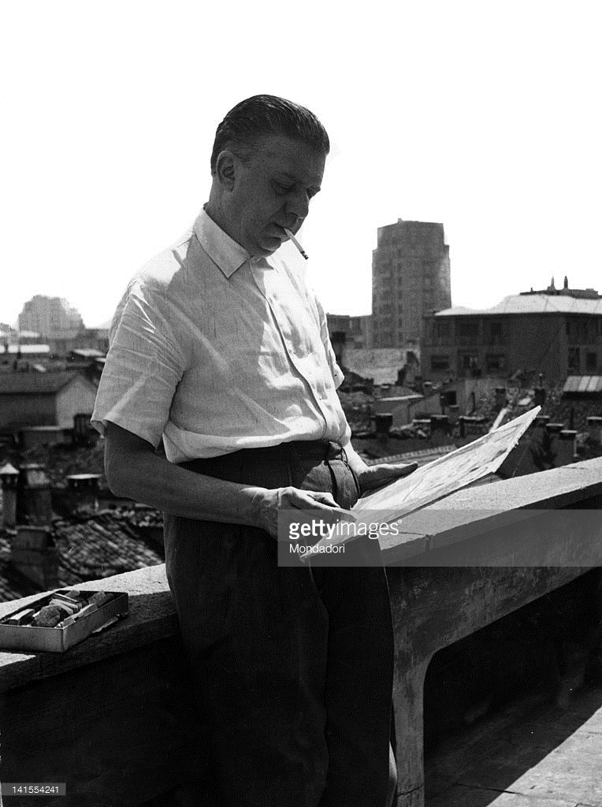
Montale on his terrace in Milan, 1966 (http://www.gettyimages.com/detail/news-photo/eugenio-montale-italian-poet-journalist-and-music-critic-on-news-photo/141554241)

Montale’s last poetic production follows along the lines of Satura, making vast use of irony and parody. In 1973 he publishes Diario del ’71 e del ’72 (Diary of 1971 and 1972), which displays an increasingly prosaic tone, with strong recourse to the logics of doubt and paradox, and to a permanent demystification of commonplaces and spiritual assumptions. In a poem such as ‘Lettera a Malvolio’ (‘Letter to Malvolio’), his poetry engages in a stark cultural critique of political Italian style, while carving out a distanced, almost alienated position for the poet.

Montale remained poetically productive for the whole decade of the Seventies, publishing Diario di quattro anni in 1977 and Altri versi in 1980 (published in the critical edition of the complete works), books in which polemical and ironical accents became all the more pronounced. The authorship of the poems in the posthumous publication Diario Postumo (1991; 1996) remains controversial until today.

Montale was awarded the 1975 Nobel Prize in Literature, and died in Milan in 1981.

Collections
Montale, E. (1980), Opera in versi. Torino: Einaudi.
Montale, E. (1984), Tutte le poesie. Milano: Mondadori.
Montale, E. (1995), Prose e racconti. Milano: Mondadori.

Translations
Montale, E. (2012), The Collected Poems of Eugenio Montale 1925-1977. Translated by William Arrowsmith. New York: W.W. Norton & Company.
Montale, E. (1998), Collected poems, 1920-1954. Translated and annotated by Jonathan Galassi. New York: Farrar, Straus and Giroux.
Montale, E. (1971), Butterfly of Dinard. Lexington: University Press of Kentucky.

Further readings
Blasucci, L. (2002), Gli oggetti di Montale. Bologna: il Mulino.
Cambon, G. (1982), Eugenio Montale’s Poetry. Princeton: Princeton University Press.
Contini, G. (1974), Una lunga fedeltà. Scritti su Eugenio Montale. Torino: Einaudi.
Greco, L., ed. (1980), Montale commenta Montale. Parma: Pratiche.
Huffman, C. de (1983), Montale and the Occasions of Poetry. Princeton: Princeton University Press.
Mengaldo, P.V. (2000), ‘L’opera in versi di Eugenio Montale’, in La tradizione del Novecento. Quarta serie, pp. 66-120. Torino: Bollati Boringhieri.

External links
A television documentary from 1999 containing fragments from interviews, readings from Montale’s poems by himself, and miscellaneous information:
http://www.raiscuola.rai.it/articoli/eugenio-montale-i-maestri-del-novecento-parte-prima/3227/default.aspx

Another short documentary realized for TV by Giuseppe Bertolucci:
http://www.lastoriasiamonoi.rai.it/puntata.aspx?id=288

